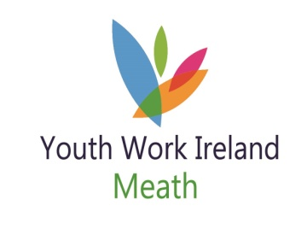 Volunteer Role Description

As a volunteer you will be offered the opportunity to take part in a variety of activities and services of Youth Work Ireland Meath.

The main activities of your role will depend on the volunteer position you apply for:

Position | Nature of work | Skills required | Time Commitment
Board Member/Director | Attend monthly meetings  Accountability  Governance  Fundraising | Knowledge of Youth Service, policies and procedures  Volunteer background  Specific skill | 6 meetings (12hrs)  Training  Available for support activities
Youth Club Leader | Work directly with young people  Participate in training  Work as part of team  Support young people  Fundraising  Committee involvement  As per individual Youth Club needs | Creative  Ability to work with others  Interest in youth activities  Patience  Listening/Communication | 2-3 hrs club night  Training  Available for support activities
Young Volunteer | Work within Youth Club  Participate in training  Work as part of team  Support young people  Fundraising  Youth Forum involvement  Assist with specific programmes and events | Creative  Ability to work with others  Interest in youth activities  Patience  Listening/Communication | 2-3 hrs club night  Training  Available for support activities
Helpers | Assist with specific programmes and events eg Youth Participation Day, Inter-Club activities | Knowledge of programme or event  Patience  Support staff & leaders | Short-term  Training

Other roles may be identified by the volunteer whereby the volunteer recognises a specific skill or knowledge they have and are willing to contribute to the development of Youth Work Ireland Meath or their local Youth Club.

We endeavour to facilitate all types of volunteers who have a specific skill and want to contribute for a specific timeframe.

