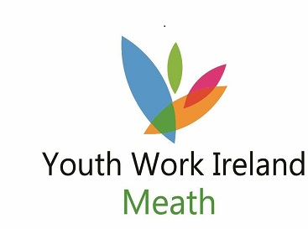
Youth Worker

Person Specification

Essential criteria
- 3rd level qualification in Youth and Community Work or equivalent
- Proven experience of working effectively in a team environment
- Experience of using strong interpersonal skills (written or oral) across a diverse and wide audience
- Experience in planning, implementing and reviewing youth work programmes and activities with young people.
- Self-motivated and able to demonstrate initiative
- Computer/Digital Media literate

Core Competencies
- Understanding of ability to apply the core principles and values underpinning youth work
- Knowledge of the development stages and issues faced by young people
- Knowledge of youth work processes
- Ability to engage and communicate with agencies, families, volunteers and young people
- Ability to lead and motivate others
- Ability to critically think and reflect on practice
- Ability to work collaboratively with others/youth work team
- Written and verbal communication skills
- Ability to maintain productive links with relevant statutory and voluntary agencies/organisations at local regional and national levels

Character
The candidate will be of good character.

Other
Car owner with full clean driver’s licence.
Garda vetting is required prior to commencement.

Requirements of Youth Work Ireland Meath staff:
- Commitment to the purpose of Youth Work Ireland Meath and to work within the values, policies and procedures of the organisation and in the context of current legislation and regulations.
- To report any areas of concern to the Regional Director in a timely fashion.
- To show flexibility in relation to hours of attendance to meeting the need of the work.
- Have a flexible approach to the work in response to organisational change, development and review of best practice.
- Identify training needs through support & supervision and participate in training opportunities appropriate to the role.
- To be vigilant to any Health, Safety and Welfare risks in the workplace and bring concerns to the Regional Director.
- To undertake your work in a manner that is friendly, flexible and professional at all times.

Terms and Conditions of Employment
Full-time working hours 35 hours Part-time working hours 18 hours
Remuneration €26,811 Remuneration €13,806
Annual leave 20 days Annual leave pro-rata

