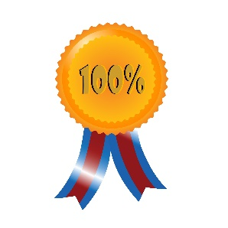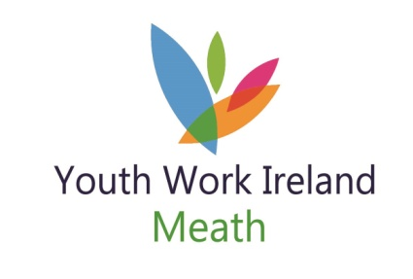

Young Person
Recognition Celebrations

Get your thinking hats on.

Look around you …. go on …… right now …… look around you.

Who do you see that inspires you?

Who earns your respect and admiration?

Who is the first person turning up or the last person leaving the club?

Who gets involved in the activities?

Who steps in and lends a hand?

Who’s first up the mountain, or into the freezing water?

Who’s a good mate?

Who knows when to listen?

Close your eyes……..who do you see?

Well then how about nominating them for

Youth Work Ireland Meath Young Person Recognition Award

The awards will be hosted on Saturday 25th May 2019
Nomination forms are available by email; on our website; by post
Closing date for Nominations will be 17th May 2018

For further details contact: Lisa Moroney – Volunteer & Youth Club Support
046-9093402 or 087-0906062

Young Person
Recognition Celebrations

Youth Club name:
Name/s of young person/s you are nominating:

Why do they inspire you?

Why have they earned your respect and admiration?

What activities did they get involved in?

What makes them a good mate?

Youth Work Ireland Meath Young Person Recognition Award

The awards will be hosted on Saturday 25th May 2019
Nomination forms are available by email; on our website; by post
Closing date for Nominations will be 17th May 2018

For further details contact: Lisa Moroney – Volunteer & Youth Club Support
046-9093402 or 087-0906062

