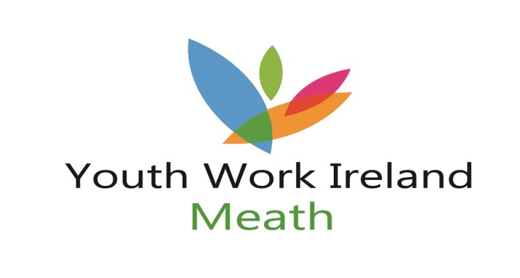

Job Title:
Youth Programmes Assistant
Base:
Youth Work Ireland Meath
St Mary’s Church Grounds
Trimgate Street
Navan

Purpose of the Post:
To provide an effective programme of events for young people in conjunction with Youth Workers and Youth Work Ireland Meath personnel.

Job Description:
- Assist YWI Meath Youth Workers with various activities/programmes
- Ensure the active participation of young people in programmes
- Keep records of all projects undertaken including evaluation of programmes
- Participate in all training provided
- Attend meetings as requested
- Any other duties as assigned by Youth Work Ireland Meath personnel

Hours of Duty: 19 ½ hrs
Will involve some evenings/weekend work

