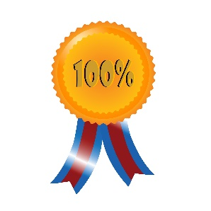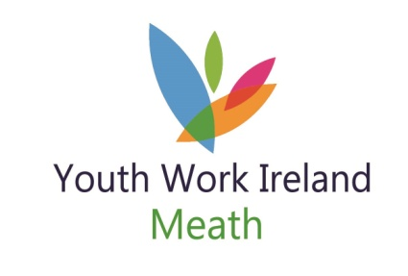

Youth Club of the Year
Recognition Celebrations

Name of Youth Club you are nominating:

What makes it a great youth club?

What activities die the youth club get involved in?

What is the youth club’s highlight moment in 2018/2019?

Any other information you’d like to share with us?

Youth Work Ireland Meath’s Volunteer Recognition Award

The awards will be hosted on Saturday 25th May 2019
Nomination forms will be available by email; on our website; by post
Closing date for Nominations will be 17th May 2019
For further details contact:
Lisa Moroney – Volunteer & Youth Club Support 046-9093402 or 087-0906062

